April 2015
Creation of New U.S. Standard General Ledger (USSGL) account to Record Accrued Interest Payable on Federal Investments/Debt for FY 2015

Purpose:
To create a USSGL account that can be used to report accrued interest payable on securities issued by the Bureau of the Fiscal Service (Fiscal Service) and other agencies with authority to issue securities.

Issue:
With the current USSGL structure interest receivable is broken out into three unique types while the reciprocating accounts for interest payable are broken out into two types as shown below:

Accrued Interest Payable | Interest Receivable
214000 Accrued Interest Payable Not Otherwise Classified | 134000 Interest Receivable – Not Otherwise Classified
214100 Accrued Interest Payable – Debt | 134100 Interest Receivable – Loans
 | 134200 Interest Receivable – Investments

While interest receivable is broken out between loans and investments, accrued interest payable is not.

Proposal:
In order to distinguish between the three types of interest payable a new USSGL could be created and the description of USSGL 214100 modified as shown below in bold italics.

Accrued Interest Payable | Interest Receivable
214000 Accrued Interest Payable Not Otherwise Classified | 134000 Interest Receivable – Not Otherwise Classified
214100 Accrued Interest Payable – Loans | 134100 Interest Receivable – Loans
214200 Accrued Interest Payable – Debt | 134200 Interest Receivable – Investments

Justification for new USSGL:
Under the current environment accrued interest payable by federal agencies on borrowings and accrued interest payable by Bureau of Fiscal Service on agency investments fall under the same reciprocal category (RC 02) with no distinction between the two. The accrued interest payable by agencies on borrowings is comingled with accrued interest payable on investments by Treasury and FFB creating an Intragovernmental reporting issue. The creation of this new USSGL and the renaming of USSGL 214100 will enable these two unique accrued interest payables to be reported separately.

Proposed Account Title: Accrued Interest Payable - Loans
Account Number: 214100
Normal Balance: Credit

Proposed Definition: The amount of interest accrued and owed to others that is the result of loans issued under general and special financing authority. This does not include accrued interest payable on securities issued by the Bureau of the Fiscal Service, Federal Financing Bank and agencies with authority to issue securities, which should be reported in USSGL account 214200. This account does not close at yearend.

Proposed Account Title: Accrued Interest Payable - Debt
Proposed Account Number: 214200
Proposed Normal Balance: Credit
Proposed Definition: The amount of interest accrued and owed to agencies that is the result of securities issued by the Bureau of the Fiscal Service, Federal Financing Bank and agencies with Authority to Issue Securities. This account does not close at yearend.

Section III

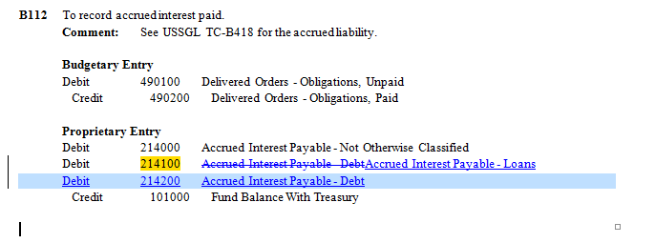

The following TCs will be updated: B112, D102, D107, D110, D134, & D308

Attribute Table:

No. | USSGL Account Title | Anticipated | Budg/Prop | Norm Bal | Begin/End | Debit/Credit | Auth Type Code | Apport Cat | Apport Cat B | Avail Time
214100 | Accrued Interest Payable - Loans | N | P | C | B/E | D/C
214200 | Accrued Interest Payable - Debt | N | P | C | B/E | D/C

BEA Cat | Borrow Source | Budgetary Impact  Indicator | Cohort Yr | Cust/ Noncust | Exch/ Nonexch | Fed/ NonFed | Trading Ptnr | Trading Ptnr Main | PY Adj | Program Indicator | Program Rpt Cat | Reimb Flag | Year of BA
 |  |  |  |  |  | F/N | ### | /####
 |  |  |  |  |  | F/N | ### | /####
Reduction Type | Fund Type | Reporting Type Code | Financing Account  Code | TAS Status | Trans. Code
 | CF/DF/EC/EG/EM/EP/ER/ES/ET/GA/TR/UG/US/UT | E/F/U | D/G/N | E/U | X/N
 | CF/DF/EC/EG/EM/EP/ER/ES/ET/GA/TR/UG/US/UT | E/F/U | D/G/N | E/U | X/N

Crosswalks Impacted:

USSGL  Account Number | Balance Sheet | Net Cost | Net Position | Custodial Activity | P&F/ SF133 | SBR | Reclassified Balance Sheet | Reclassified Statement of Net Cost | Reclassified Statement of changes in Net Position
214100 | Line 18 & 23 | N/A | N/A | N/A | N/A | N/A | Line 6.2 & 7.4 | N/A | N/A
214200 | Line 18 & 23 | N/A | N/A | N/A | N/A | N/A | Line 6.2 & 7.4 | N/A | N/A

