Offsetting receipts are collections credited to general fund, special fund, or trust fund receipt accounts. They offset gross outlays at the agency or Governmentwide level and may be distributed or undistributed. Distributed offsetting receipts offset the outlays of the agency, while undistributed offsetting receipts offset Governmentwide outlays. Typically, distributed offsetting receipts offset the outlays of the agency that conducts the activity generating the receipts and the subfunction to which the activity is assigned. This line item on the SBR (19C) should include all distributed offsetting receipts for the agency. (Refer to OMB Circular No. A-136, as revised June 2008.)

The Bureau of the Fiscal Service (Fiscal Service) has established new guidance in the Quarterly Receipts by Department Report. This report provides detailed information for transactions reported on the Statement of Transactions (Fiscal Service 224, Fiscal Service 1220, and Fiscal Service 1221) for the distributed offsetting receipts reflected in the Monthly Treasury Statement of Receipts and Outlays of the United States Government (MTS). Agencies can use the Quarterly Receipts by Department Report as an additional tool to assist with identifying and resolving differences between monthly budgetary reporting and the distributed offsetting receipts found on the SBR (19C) for each identified Governmentwide Accounting (GWA) Treasury Account Symbol (TAS).

Distributed offsetting receipts include the following categories:

- Proprietary receipts from the public;
- Intrabudgetary receipts deducted by agencies; and
- Offsetting governmental receipts.
The following is an illustration of the fourth-quarter Quarterly Receipts by Department Report. The report includes several columns:

MTS Line Code – Explains where a specific agency’s receipt accounts will post on the MTS.

Department Regular (DR) Code – Is the Department of the Treasury- (Treasury) designated code representing the Government agency accountable for one or more fund accounts established and maintained by Treasury. The DR code is an integral part of the Treasury Appropriation Fund Symbol (TAFS).

Department Transfer (DT) – Identifies a Federal agency that is transferring budget or obligational authority to one of its components. For a direct transfer of budget authority, the transfer agency relinquishes responsibility for the funding transferred. For a transfer of obligational authority, the transfer agency retains responsibility for the fund account and the recipient agency charges against the fund account of the transfer agency.

Fiscal Year – Identifies the availability and account type (that is “X,” indefinite account, or “F,” clearing account).

Main Account – Is identified by a four-digit numeric data element representing a specific appropriation or fund account established by Treasury for expenditure or receipt authority issued by the U.S. Congress. The initial digit of the main account is used to classify the fund type, for example, 8XXX identifies a trust fund and 0XXX identifies a general fund, followed by the account number (XXX).

Sub-Account Symbol – Is used to specify subsidiary level accounts associated to the main account of the TAFS. The sub-account might indicate a series of subsidiary level receipt accounts or represent special subsidiary level accounts requested for use by an agency and approved by Treasury. Subaccount balances aggregate to the main account balance. The subaccount has the potential for several relationships to the main account. Generally, 900-series sub-accounts indicate special Treasury investment categories and are the result of special transaction sets that Treasury identifies with the subclassification code, which is a prefix of the main account. The associated sub-account and subclassification codes make it possible for Treasury to report on selected investment categorizations.

Transaction Code (TC) – Is a two-digit transaction identifier, which is the result of the type of activity classified by agencies on their Statement of Transactions reporting, that is, 51-Unavailable Receipts, 61-Disbursements, 16-Offsetting Receipts, 17-Receipts.

Quarter Total – Is the current quarter amount reported for a specific receipt account. This amount should be reconciled to the GWA Account Statement.

Current Year to Date – Is the sum of all quarter amounts reported for a specific receipt account.

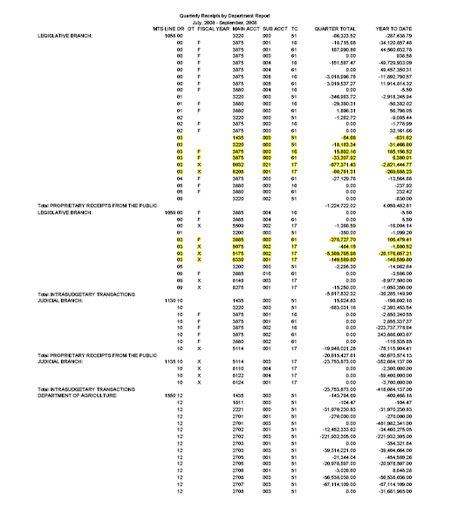

The Quarterly Receipts by Department Report will be available at https://www.fiscal.treasury.gov/fsreports/rpt/mthTreasStmt/current.htm on the eighth workday of January, April, July, and October each year.

Direct questions concerning information found in the Quarterly Receipts by Department Report to:

Budget Reports Division
Financial and Budget Reports Directorate
Governmentwide Accounting
Bureau of the Fiscal Service
Department of Treasury
3700 East-West Highway
Hyattsville, MD 20782
Telephone: 202-874-9880
E-Mail: budget.reports@fiscal.treas.gov

