Profile of the Economy
(Office of Macroeconomic Analysis)
November 27, 2024
Introduction
The U.S. economy continued to demonstrate robust growth in the third quarter, with real GDP increasing 2.8 percent, supported by strong private domestic demand. Although the pace of job growth moderated, this partly reflected exogenous factors such as weather and labor strikes. Meanwhile, other aspects of the labor market improved: real earnings growth was solid, the balance between labor supply and demand continued to mend, and initial unemployment claims remained near historically low levels.

Notably, inflationary pressures receded in the third quarter such that the Federal Reserve’s preferred measure—the Personal Consumption Expenditure (PCE) price index—slowed to within a tenth of a percentage point of the 2 percent inflation target as of September. Households’ moods, however, have remained somewhat depressed amid reported concern over persistently elevated price levels, but —after accounting for changes in survey methodology—the outlook for the economy’s future has improved among consumers, businesses, and builders.

Economic Growth
Real GDP growth increased by 2.8 percent at an annual rate in the third quarter of this year, according to the advance estimate, slowing modestly from the second quarter’s 3.0 percent pace. A marked acceleration in private consumption drove much of the latest quarter’s expansion, but growth was also supported by public expenditures and business fixed investment (BFI).

Decomposing GDP into smaller components can be helpful in explaining the economy’s performance. The four components we consider are: (1) private domestic final purchases (PDFP), the most persistent and stable component of output, consisting of personal consumption expenditures (PCE), BFI, and residential investment; (2) government consumption and investment; (3) net international purchases (U.S. exports less U.S. imports); and (4) intermediate demand (or the change in private inventories). Examined separately, each component delivers specific information about activity in various sectors that can also be useful in predicting the future path of growth.

The first component, PDFP, is particularly important to analyze: it measures the private sector’s capacity to drive self-sustaining growth and, therefore, may signal the direction of future economic performance. In the third quarter, real PDFP growth was 3.2 percent at an annual rate—or 0.5 percentage points above the second quarter pace—and accounted for 2.7 percentage points of total GDP growth.

Personal consumption of goods and services accelerated sharply to 3.5 percent at an annual rate in the third quarter, following a 2.8 percent gain in the second quarter. PCE made the largest contribution to GDP growth of any component (2.4 percentage points). Purchases of goods rose by 5.6 percent, double the second quarter’s pace, while growth of expenditures on services was 2.6 percent, just shy of the growth rate in the previous quarter.

BFI grew by 3.8 percent at an annual rate in the third quarter, near the second quarter’s 3.9 percent pace. Investment in real equipment surged by 10.6 percent in the third quarter, the fastest rate since 2023 Q2, after a 9.8 percent advance in the second quarter. Intellectual property products investment increased for the seventeenth consecutive quarter, but the 2.5 percent gain was the weakest pace so far in the post-pandemic recovery. By contrast, investment in business structures declined outright for the first time since 2021’s fourth quarter, falling 4.7 percent. Amid the pull-back in structures spending, growth in business investment in manufacturing structures—which had been robust since mid-2021—declined 3.1 percent at an annual rate in the third quarter of 2024.

Residential investment, the final component of PDFP, dropped by 5.2 percent in the third quarter, following a 2.8 percent decline in the second quarter. These decreases reflected a retreat in the construction of single-family homes as well as multifamily structures. Even so, residential investment spending only subtracted 0.2 percentage points from real GDP growth in the third quarter.

Of the remaining major components of GDP, only government spending made a positive contribution to economic growth in the third quarter. Government spending added 0.8 percentage points to GDP growth, mostly reflecting a 0.5 percentage point addition from federal purchases for national defense goods and services. The contribution from state and local governments held steady at 0.3 percentage points. Meanwhile, the change in private inventories, which can exhibit wide swings from quarter to quarter, subtracted 0.1 percentage points from real GDP growth, slipping from a 1.1 percentage point contribution in the second quarter. Turning to net exports, growth rates of both exports and imports surged in the third quarter, but the pace of import growth still exceeded that of exports, leaving the trade deficit at its widest in over two years. Net exports subtracted 0.6 percentage points from GDP growth in the third quarter—although this was less than the 0.9 percentage point drag in the second quarter.

Growth of Real GDP
(Quarterly percent change at annual rate)
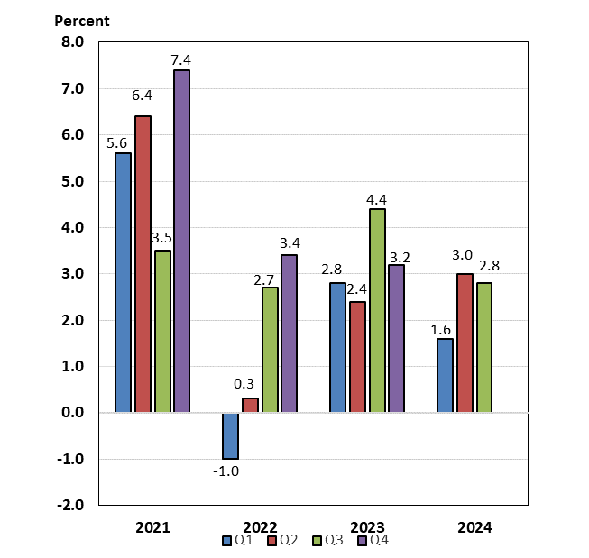

Labor Markets and Wages
Labor data suggest that labor markets have largely returned to a normal supply-demand balance thus far in 2024. Payroll job growth has gradually slowed from the rapid rates that dominated 2021 and 2022—roughly 600,000 and 375,000 jobs on average per month, respectively—to an average of 148,000 in the third quarter of 2024. Although the latest labor report indicated that payrolls were barely changed over the month, up by just 12,000 jobs in October, job growth was likely constrained by labor strikes as well as the impact of severe hurricanes in late-September and early-October. So far in 2024, job growth has averaged 170,000 per month, near estimates of the break-even rates needed to maintain a steady unemployment rate given population growth. Recent studies suggest that elevated population growth in the past few years contributed to a higher base level of job growth needed to maintain a stable unemployment rate. According to the Federal Reserve Bank of Dallas, the upper end of estimates of breakeven job growth was around 200,000 jobs, roughly double the estimated breakeven pace before the pandemic. Given the recent easing of immigration—a key driver of population growth—the breakeven pace of job growth may have decreased and the current average pace of job growth this year may be sufficient to maintain a stable unemployment rate.

Meanwhile, the unemployment rate has crept lower in recent months after reaching a peak of 4.3 percent in July. In September and October, the unemployment rate stood at 4.1 percent—or only 0.4 percentage points above the year-end rate in 2023. A broader measure, which captures underemployment of the workforce, has risen 0.6 percentage points to 7.7 percent from December 2023 to October 2024. Both the unemployment and underemployment rates remain relatively low by historical standards. More timely data also suggest that unemployment remains low. As of the latest releases for mid-November, the level of initial unemployment insurance claims has increased by about 8 percent from the end of December 2023, while continuing unemployment claims have drifted up by about 9 percent. Even after recent hurricane-related increases, these readings are only marginally above those in February 2020, just before the start of the COVID-19 pandemic in the United States.

The labor force participation rate (LFPR) was stable during the third quarter, helping to maintain the supply of workers. From July to September, the overall LFPR held steady at 62.7 percent before ticking down to 62.6 percent in October. Prime-age (ages 25-54) worker participation continues to underpin overall participation: after reaching a 23-year high of 84.0 percent in July, the prime-age LFPR drifted somewhat lower, standing at 83.5 percent in October. Despite the recent easing, the prime-age LFPR is up 0.2 percentages points over the year and is 0.4 percentage points above the peak just before the pandemic.

In addition to resilient labor supply, more moderate labor demand has helped to restore balance in the labor market. The number of job openings (or vacancies) has declined by roughly 20 percent over the year ending September (latest data available), extending a downward trend which began in March 2022. The ratio of job vacancies to unemployed workers also has gradually declined since the spring of 2022; as of September, there were 1.1 job openings per unemployed worker, down from the pandemic-high of 2.0 vacancies but slightly below the pre-pandemic peak. The combination of stable labor supply at high levels (mainly due to elevated participation) and a more pronounced downtrend in job openings continues to foster an ongoing rebalancing of labor supply and demand.

Measures of wage growth in the private sector have been stable to slower during the first three quarters of 2024. Looking at quarterly averages of twelve-month growth rates, earnings grew 4.3 percent in the first quarter of 2024, then slowed to 3.9 percent in the second quarter and grew 3.8 percent in the most recent quarter. Nonetheless, earnings grew 4.0 percent in October, the fastest pace since April 2024. These annual rates are considerably below the post-pandemic peak of 5.9 percent in March 2022, but higher than the 3.0 percent rate over 2019. Importantly, growth of earnings in real terms has shown a strongly upward trend in recent months. Real average hourly earnings were up 1.4 percent over the year through October, double the 0.7 percent gain over the year through July. In fact, twelve-month gains have averaged 1.4 percent over the most recent three months through October, attesting to the improvement in real wage gains. An alternative measure of wage growth, the Employment Cost Index (ECI), suggests that wage pressures have receded further in recent quarters. (The ECI controls for employment shares among industries and occupations, making it a better reference for wage growth.) Over the four quarters through September 2024, the ECI for private sector wages and salaries grew 3.8 percent, after rising 4.1 percent in the second quarter. ECI growth has gradually slowed since reaching a 38-year high of 5.2 percent in March 2022.

Payroll Employment
(Monthly average for year shown and monthly amounts, in thousands)

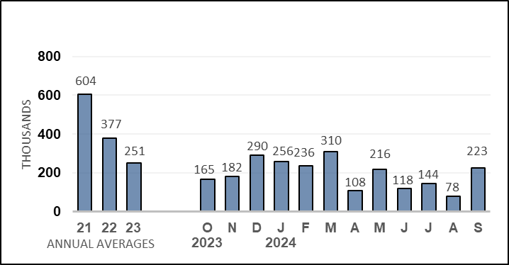

Unemployment Rate
(Percent)
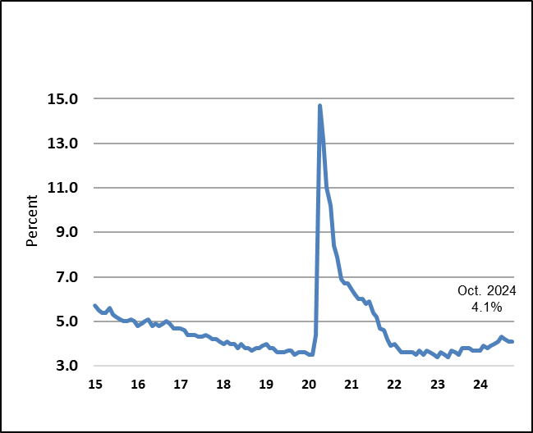

Prices
Over the past two years, inflation has cooled significantly. After peaking in June 2022 at 9.1 percent, headline inflation as measured by the consumer price index (CPI) was 2.4 percent over the twelve months through September, the slowest pace since February 2021, before picking up slightly to 2.6 percent over the year through October. On a monthly basis, inflation readings have stabilized at low levels: in October, CPI inflation was 0.2 percent, matching the pace in the previous three months.

Energy price inflation was negative in the second and third quarters on an average monthly basis before leveling off in October. Over the year through October, energy price deflation was 4.9 percent. The downtrend reflected some de-escalation of geopolitical tensions, prospects for increased production among OPEC+ members, and concerns about prospects for future growth in the United States and China.

Meanwhile, food price inflation has remained relatively stable and close to rates observed prior to the pandemic: monthly food inflation has averaged 0.2 percent over the past four months. Over the year through October, food price inflation was 2.1 percent, less than one-third the peak rate in the autumn of 2022 and just above the pace of inflation seen before the pandemic.

Core inflation, which excludes energy and food, has fluctuated this year in a range of 0.2 percent to 0.4 percent. Core inflation slowed over the summer to the low end of this range but averaged 0.3 percent in over the past three months. Core goods prices had been on a declining trend since mid-2023 but flattened out on average over the past three months. In October 2024, core goods inflation was unchanged, reflecting offsetting deflation for nondurable goods and inflation for durable goods. Nonetheless, core goods prices were 1.0 percent lower on a twelve-month basis through October.

Core services inflation remains the driving force behind core CPI inflation, averaging 0.3 percent per month over the past four months. Among core services, rent of housing services (rent of primary residential and owners’ equivalent rent) contributes the largest share of core inflation. Rent of housing inflation averaged 0.4 percent per month in the third quarter, matching the second quarter’s average pace. Although these rates are still above those consistent with a 2.0 percent target rate for total inflation, they are well down from the 0.7 percent to 0.8 percent monthly rates seen in the latter half of 2022. Prices are now hovering at the bottom of the 0.4 percent to 0.5 percent range that has largely persisted—save for two months—since May 2023. Over the twelve months through October 2024, this component rose 5.1 percent, tied for the slowest rate since the spring of 2022.

Inflation for non-housing core services has also been an integral driver of elevated core inflation. In the third quarter and October, non-housing core services inflation averaged 0.3 percent growth per month, picking up from an average of 0.1 percent in the second quarter. The faster pace of core non-housing services inflation largely reflected an upturn in airfares, which switched from a modest drag on inflation in the second quarter to a moderate boost in the third quarter. Core non-housing services inflation also reflected somewhat stronger growth in prices for motor vehicle insurance and repairs.

Inflation as measured by the PCE price index is the Federal Reserve’s preferred measure of inflation, and the FOMC’s 2 percent inflation target is expressed in terms of headline PCE, although core PCE inflation is also taken into consideration. There are notable differences in weights and methodologies between the CPI and the PCE measures. Historically, twelve-month CPI inflation has exceeded PCE inflation by about 0.4 percentage points on average. This year, however, the wedge has widened, reaching 0.8 percentage points in April and averaging 0.6 percentage points in the first half of this year. With the recent slowing in OER, the wedge has narrowed, averaging 0.3 percentage points over the past four months. Headline PCE inflation was 2.3 percent over the twelve months through October—or 0.3 percentage point above the FOMC inflation target—while core PCE inflation was 2.7 percent.

Consumer Prices
(Percent change from a year earlier)
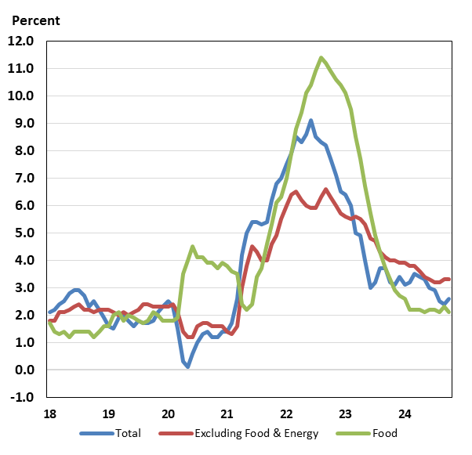

Nonfarm Productivity of Labor
Reflecting continued strong growth in real GDP, productivity growth accelerated in the third quarter of 2024. Nonfarm productivity growth was 2.2 percent, somewhat faster than the 2.1 percent pace during the second quarter and more than three times faster than the first quarter’s 0.7 percent pace. Productivity growth reflected a 3.5 percent advance in real output, which more than offset a 1.2 percent increase in worker hours. Over the four quarters through Q3, productivity was up 2.0 percent, slowing from the year-earlier 2.7 percent four-quarter increase. Nonetheless, this marked the sixth consecutive quarter of positive annual growth.

Even with faster productivity growth in the third quarter, worker compensation slow moderately on a quarterly basis. Nominal hourly compensation costs in the nonfarm business sector rose 4.2 percent at an annual rate in the third quarter, after a 4.6 percent increase in the second quarter—although both rates were less than half the first quarter’s 9.3 percent gain. On a year-over-year basis, worker compensation was up 5.5 percent through 2024 Q3, up from the 3.9 percent pace a year earlier. Combined with slowing inflation, compensation saw solid real gains in the third quarter. Real compensation per hour rose 3.0 percent at an annual rate, almost double the second quarter’s 1.7 percent pace and returning to the first quarter’s pace. Over the most recent four quarters, real compensation growth picked up to 2.8 percent, up significantly from the 0.3 percent pace over the year-earlier period.

After surging in the first quarter, unit labor costs have since slowed markedly on a quarterly basis. Unit labor costs, defined as the average cost of labor per unit of output, slowed to 1.9 percent at an annual rate in the third quarter, following a 2.4 percent increase in the second quarter and a 8.5 percent jump in the first quarter. Over the four quarters through Q3, growth of unit labor costs was 3.4 percent, nearly three times the 1.2 percent growth over the four quarters through the third quarter of 2023.

Industrial Production, Manufacturing, and Services
Industrial production—that is, the output of manufacturing businesses, mining, and utilities—has been relatively flat for more than two years. In the third quarter of 2024, output at factories, mines, and utilities increased 0.2 percent on average each month, fully offsetting the 0.2 percent average gain during the second quarter. In October, industrial production decreased another 0.3 percent in October, owing in part to strikes (such as the now-resolved strike at Boeing) and impacts from hurricanes in late-September and early-October. Over the twelve months through October, though, output was down 0.3 percent.

Manufacturing production, which accounts for about three-quarters of all industrial output, has trended lower since autumn of 2022. This year on an average monthly basis, output ticked up by 0.1 percent in the first quarter, was flat in the second quarter, and declined by 0.1 percent in the third quarter. Partly owing to hurricanes and the strike, factory output fell by another 0.5 percent in October. Despite persistent growth in output among high-tech manufacturers, automotive production has declined on balance since March 2024 and other manufacturing has trended lower since April 2022.

Mining output (14 percent of industrial production) tends to fluctuate from month to month but, nonetheless, has trended down since autumn of 2023. Over the third quarter, mining output declined by 0.3 percent on average. In October, though, mining output rebounded 0.3 percent, reflecting a partial recovery from September’s hurricane-induced declines in oil and gas extraction. The final component of industrial output is utilities production, which tends to fluctuate due to weather; unseasonable weather in months often causes sharp swings in output from one month to the next. In October, utilities production increased by 0.7 percent, rebounding from September’s hurricane-related decrease.

National surveys of manufacturing businesses continue to signal weak activity, while national surveys for services indicate modest but strengthening expansion. The Institute for Supply Management’s (ISM) manufacturing index rose above the 50-point growth threshold in March 2024 for the first time since late 2022, but the improvement was short-lived. Since March, the index has trended lower and, as of October, stood at 46.5, marking a fifteen-month low and signaling moderate business contraction. For the services sector, the ISM’s index dipped below the growth threshold of 50 in both April and June but has since trended higher, reaching 56.0 in October, the highest level since July 2022. This index has signaled growth in the national services sector in 20 of the last 22 months.

Housing Markets
After an overall slowing during the first half of 2024, housing activity has been mixed in recent months.

Net single-family planned and new construction improved over the third quarter, while multi-family construction has decreased on net. But activity for October weakened on balance, likely reflecting recent hurricanes. In the third quarter, single-family permits increased an average of 0.6 percent per month, while single-family starts have risen by 1.5 percent on average. October, however, saw a divergence between single-family permits and starts, with the former increasing another 0.8 percent while the latter fell 6.9 percent. Moreover, planned and new home construction levels were lower over the past year.

By contrast, levels of planned and new construction for multi-family units (condominiums, co-ops, and apartment buildings) decreased over the third quarter. Permits decreased 2.7 percent on average from July to September and fell another 3.0 percent in October, portending future weakness in this segment of the market. Meanwhile, starts were lower over the quarter (down 2.6 percent on average each month) but rebounded 9.6 percent in October.

Continuing and completed construction activity worsened on balance over the past four months. The inventory of total homes under construction ticked down by an average of 1.2 percent per month in the third quarter, owing to less construction of both single- and multi-family homes. Construction inventories fell another 1.9 percent in October to 1.465 million, well down from the record high of 1.710 million reached in October 2022 (data series begins in 1970). However, builder confidence, as measured by the National Association of Home Builder’s Housing Market Index, has turned up recently; after dropping to an eight-month low in August 2024, home builder sentiment has risen in the three subsequent months, including November’s increase to 48.

Meanwhile, home sales remain near lows last seen in the aftermath of the global financial crisis. Existing home sales—which account for a supermajority of all home sales—declined an average of 0.5 percent per month in the third quarter and annual sales were persistently negative from August 2021 to September 2024. In October 2024, however, existing home sales rebounded modestly and annual growth turned slightly positive at 2.9 percent growth over the year. Since July 2022, by contrast, new single-family home sales have been roughly in line with sales levels during 2018 and2019. New home sales currently account for only about 15 percent of total home sales. Due to hurricane-related disruptions, sales dropped 17.3 percent in October and were 9.4 percent lower over the year.

After showing solid improvement during the first half of this year, inventories of existing homes available for sale have stabilized at higher levels in recent months. Months’ supply of existing homes for sale stood at 4.2 months in October, just slightly higher than the inventory-sales ratio at the end of the third quarter. Nonetheless, the level of inventories remains historically low as current homeowners are locked into low, pandemic-era rates. The new homes market does not suffer from the same lock-in effect, and inventories are well above pre-pandemic levels. Inventories of new homes on the market have risen by an average of 0.7 percent per month since June and, as of October, were equivalent to 9.5 months of sales. Before the pandemic, a supply of roughly 6 months was typical for the new home market.

Movements of home price growth rates have been mixed from month to month as well as on a twelve-month basis, but relative to peaks, home price growth has slowed considerably. The Case-Shiller 20-city house price index—which measures sales prices of existing homes—has risen somewhat slowly this year; during the third quarter, this index increased by an average 0.2 percent per month, modestly slower than the second’s quarter’s 0.3 percent advance. Over the year ending September 2024, the 20-city index was up 4.6 percent, faster than the 4.0 percent, year-earlier decline (but well down from the 21.3 percent recent twelve-month peak rate posted in April 2022). On the other hand, the FHFA purchase-only house price index showed accelerating price growth in the third quarter: on average, prices rose 0.3 percent per month, thrice the average rate observed in the second quarter. However, over the year through September 2024, the FHFA measure was up 4.4 percent, slowing from the 6.2 percent pace over the year through September 2023 (and roughly one-fifth of the peak rate of 18.9 percent posted over the year through July 2021).

Consumer and Business Sentiment
The flagging of business and consumer mood observed in the second quarter has given way to a limited improvement in more recent months. Early in the third quarter, the Reuters/Michigan consumer sentiment index declined to 66.4 in July. However, recent analysis has indicated that a change in survey methodology—a transition from phone interviews to a fully online survey—can explain a significant share of the decline in Michigan Index of Consumer Sentiment since early 2024. The survey transition was fully complete by July, and the sentiment index has since moved modestly higher, reaching 71.8 in November and up 10.5 points over the year. The latest survey registered consumers’ more positive outlook about the economy’s future in the resolution of the presidential election. Meanwhile, views about current economic conditions held steady, and views about the future path of inflation were mixed: year-ahead inflation expectations declined further, but five-year inflation expectations increased.

The Conference Board’s alternative household sentiment survey has not had a similar methodological change, making interpretation of sentiment changes relative to earlier in 2024 simpler. The headline consumer confidence has trended higher—albeit inconsistently—since the spring. By October (latest available data), the index had reached 108.7, the highest level this year. The expectations component has largely driven the increase in the headline index, while the present situation index has been relatively flat. The consumer confidence index remains well above the January 2021 low of 87.1 but significantly lower than the June 2021 post-pandemic high of 128.9.

Turning to private firms, the National Federation of Independent Business’s (NFIB) small business optimism index has also improved on balance since the spring of this year. In July, the optimism index rose to the highest level in over two years and, while subsequent surveys saw optimism drift lower, the reading in October had fully returned to July’s level. Nonetheless, the headline small business index has not recovered fully from the pandemic and even remains almost 5 percent below the 50-year average. Among component indices, small business owners had mixed views: expectations of improved sales six months ahead fell to the lowest since July 2020, but expectations about economic performance six months ahead jumped to a four-year high.

Federal Budget Deficit and Debt
In FY 2024, the deficit increased $138 billion to $1.83 trillion (6.4% of GDP) as an increase in outlays more than offset rising receipts. Outlays rose by $617 billion to $6.75 trillion (23.4% of GDP) in FY 2024, partly reflecting increased net interest payments on the federal debt, a sharp drop in proprietary receipts by the Department of Education, and higher spending on Social Security and Medicare due to demographic aging. Meanwhile, total federal receipts jumped by $479 billion to $4.92 trillion (17.1% of GDP) in FY 2024. The rise in receipts was partly due to strong labor markets (which pushed up individual income tax withholdings and social insurance receipts), capital gains realizations, and the payment of some delayed taxes from FY 2023 (such as from households impacted by natural disasters).
In June 2023, the Treasury’s borrowing limit was suspended until early 2025. At the end of FY 2024, gross federal debt held by the public stood at $35.5 trillion, while debt held by the public was $28.3 trillion.

Monetary Policy
The Federal Open Markets Committee (FOMC) began raising its policy rate at its meeting in March 2022 to address inflationary pressures in the economy. From March 2022 to July 2023, the FOMC increased the short-term policy rate target range from 0.00-0.25 percent to 5.25–5.50 percent. More than a year later—at the meeting in September 2024—the Committee initiated the current monetary easing cycle with a 50 basis point cut, followed by another cut of 25 basis points at the early-November meeting. Currently, the target range stands at 4.50-4.75 percent.

In the accompanying statement, the FOMC repeated the previous observation that “economic activity has continued to expand at a solid pace” but added in new language, noting that “labor market conditions have generally eased” since earlier in the year. During the post-FOMC meeting press conference on November 7, Chair Powell said, “[t]his further recalibration of our policy stance will help maintain the strength of the economy and the labor market and will continue to enable further progress on inflation as we move toward a more neutral stance over time.”

