f. 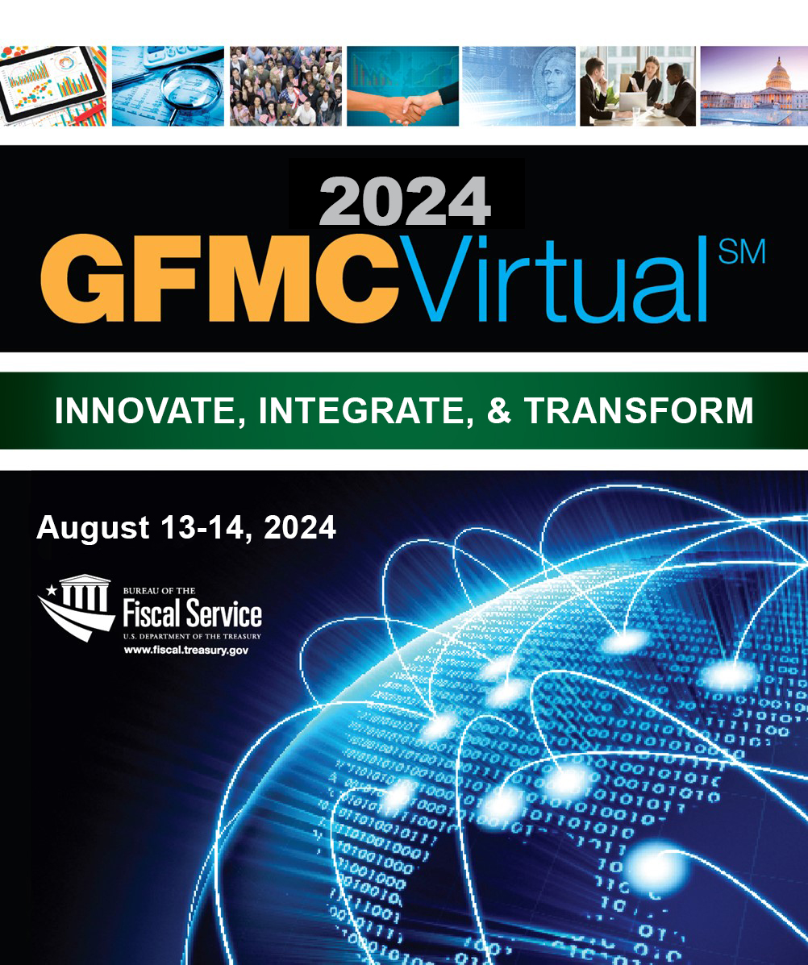F

**Innovate, Integrate, & Transform**

**WELCOME TO THE**

**2024 GFMC*Virtual*SM**

Welcome to the 2024 GFMC*Virtual*SM. This two-day **group internet-based event**, sponsored by the Department of the Treasury’s Bureau of the Fiscal Service, will allow you to earn up to 10 continuing professional education (CPE) credits. All educational sessions will be led by federal financial management experts from the Bureau of the Fiscal Service and select partners.

We look forward to your participation in the 2024 GFMC*Virtual*SM. For more conference and training details, visit www.fiscal.treasury.gov. For more information on the federal financial management (FM) vision, visit <https://fmvision.fiscal.treasury.gov/>.

The Bureau of the Fiscal Service is registered with the National Association of State Boards of Accountancy (NASBA) as a sponsor of continuing professional education on the National Registry of CPE Sponsors. State boards of accountancy have final authority on the acceptance of the individual courses of CPE credit. Complaints regarding registered sponsors may be submitted to the National Registry of CPE Sponsors through this website: www.nasbaregistry.org.

**CONFERENCE PROGRAM CONTENTS**

Conference Schedule Grid / Tuesday August 13…………………………………………………………………………………. Page 2

Conference Schedule Grid / Wednesday August 14…………………………………….…….…………………………………Page 3

Session Descriptions…………………………………………………………………………………………………………………….………Page 4

Conference details……………………………………………………………………………………………………….…………………….Page 11

**GFMC*Virtual*SM Schedule: August 13, 2024**

|  |  |  |  |
| --- | --- | --- | --- |
| **Time** | **Event** | **CPEs** | **Minutes** |
| **9:00 AM -9:50 AM** | The Future of Federal Financial Management | 1 | 50 |
| **9:50 AM - 10:00 AM** | **10-minute Break** |  | 10 |
| **10:00 AM - 10:50 AM** | **Office of Payment Integrity Services & Solutions:**  **Right Person, Right Amount, Right Time** | 1 | 50 |
| **10:50 AM - 11:00 AM** | **10-minute Break** |  | 10 |
| **11:00 AM - 11:50 AM** | **Optimizing Transparency: Enhancing Sub-Award**  **Data Accuracy on USAspending** | 1 | 50 |
| **11:50 AM -1:00 PM** | **Lunch** |  | 70 |
| **1:00 PM - 1:50 PM** | **Central Receivables Services - At the Crossroads of Compliance and Modernization** | 1 | 50 |
| **1:50 PM -**  **2:00 PM** | **10-minute Break** |  | 10 |
| **2:00 PM - 2:50 PM** | Strengthen Financial Reporting with the Implementation of G-Invoicing and Reduction of IGT differences | 1 | 50 |

**GFMC*Virtual*SM Schedule: August 14, 2024**

|  |  |  |  |
| --- | --- | --- | --- |
| **Time** | **Event** | **CPEs** | **Minutes** |
| **9:00 AM -9:50 AM** | **Treasury Guidance: What Agencies Need to Know About Current Resources and Future Plans** | 1 | 50 |
| **9:50 AM - 10:00 AM** | **10-minute Break** |  | 10 |
| **10:00 AM - 10:50 AM** | **Auditability of the Financial Report and General Fund of the U.S. Government: What’s Left to Do and What’s It To You** | 1 | 50 |
| **10:50 AM - 11:00 AM** | **10-minute Break** |  | 10 |
| **11:00 AM - 11:50 AM** | **Fiscal Service Technology Changes: How Will Agencies Be Impacted?** | 1 | 50 |
| **11:50 AM -1:00 PM** | **Lunch** |  | 70 |
| **1:00 PM - 1:50 PM** | **Decade of Progress: Unleashing Government**  **Spending Insights with the DATA Act** | 1 | 50 |
| **1:50 PM -**  **2:00 PM** | **10-minute Break** |  | 10 |
| **2:00 PM - 2:50 PM** | **The Evolution of USSGL guidance and GTAS Reporting: Enhancing Accuracy and Transparency** | 1 | 50 |

**Session Descriptions**

###### Future Vision of Federal Financial Management

##### Tuesday, August 13: 9:00 to 9:50 a.m.

**Program Description**: With an eye toward the future, the Fiscal Assistant Secretary of the U.S. Department of the Treasury, Commissioner of the Bureau of the Fiscal Service, and principal members of Treasury’s Bureau of the Fiscal Service leadership team will discuss the 2024 future of federal financial management. Join us for this unique opportunity to hear where federal financial management leaders are heading. <https://fmvision.fiscal.treasury.gov>.

###### Learning Objectives: During this session, you will gain a deeper understanding of trends shaping the federal financial management community over the next few years. You will also learn how this supports your organization’s ability to achieve its financial management goals and objectives.

###### Prerequisites and Advance Preparation: None

###### Field of Study: Finance-Technical (FINT)

###### Program Level: Basic

###### NASBA CPE Credits: 1 CPE

###### Speakers:

*Dave Lebryk, Fiscal Assistant Secretary, Department of Treasury*

*Fiscal Service Leadership Team*

##### **Office of Payment Integrity Services & Solutions: Right Person, Right Amount, Right Time**

##### Tuesday, August 13: 10:00 to 10:50 a.m.

**Program Description**: Improving payment integrity is a critical component of Fiscal Service's vision for the Future of Federal Financial Management. During this session, participants will learn about Treasury’s Bureau of the Fiscal Service’s Office of Payment Integrity’s (OPI) suite of services and solutions, such as Do Not Pay (DNP) and Account Verification Service (AVS), which prevented and/or recovered an estimated $652.7 million in improper payments for federal agencies and federally funded state-administered program partners in Fiscal Year 2023. As part of this session, you will hear case studies & testimonials from OPI partners that demonstrate the impact of payment integrity services and solutions.

###### Learning Objectives: Learn how Fiscal Service can assist federal agencies in maintaining payment integrity by providing services and solutions such as Do Not Pay, Account Verification Service and Cross Government Data, which can be used in efforts to reduce improper payments and fraud.

###### Prerequisites and Advance Preparation: None

###### Field of Study: Finance-Technical (FINT)

###### Program Level: Basic

###### NASBA CPE Credits: 1 CPE

###### Speakers:

*Kevin McDaniels, Senior Advisor for Office of Payment Integrity, Bureau of the Fiscal Service*

*Denise Davis, Director, Return Integrity Verification Program Management, Internal Revenue Service*

*Jonathan Thomas, Reports Analyst, Recovery Directorate, Federal Emergency Management Agency*

##### **Optimizing Transparency: Enhancing Sub-Award Data Accuracy on USAspending**

##### Tuesday, August 13: 11:00 to 11:50 a.m.

**Program Description**: Unlocking the full potential of transparency in federal financial assistance requires a concerted effort to refine sub-award data reporting. Mandated by the Federal Funding Accountability and Transparency Act of 2006 (FFATA), recipients of federal prime financial assistance awards, including state government agencies, play a pivotal role in reporting sub-awards to the FFATA Subaward Reporting System (FSRS).

Reporting challenges have given rise to data quality and completeness, ranging from duplicate subawards to unreported and inaccurately documented subawards.

###### Learning Objectives: During this session you will learn about common subaward reporting challenges and gain understanding of how these challenges lead to subaward data quality issues. You will also learn techniques to assess the data quality of a set of subaward data on USAspending.

###### Prerequisites and Advance Preparation: None

###### Field of Study: Finance-Technical (FINT)

###### Program Level: Basic

###### NASBA CPE Credits: 1 CPE

###### Speakers:

*Drew Keller, Data Fellow, White House Office of Science and Technology Policy*

*Ben Turse, Product Owner/Data Scientist, Bureau of the Fiscal Service*

##### **Central Receivables Services - At the Crossroads of Compliance and Modernization**

##### Tuesday, August 13: 1:00 to 1:50 p.m.

**Program Description:** This session will cover the Centralized Receivables Service program mission, vision, and development prospectus. It will elaborate on how the program has transitioned to a more performant and agile receivables management platform that affords agencies the convenience of profile customizations and the expansion of digital functionality deployed in a compliance environment.

###### Learning Objectives: This session will demonstrate how receivables management is being transformed through the Centralized Receivables Service’s 2.0 platform.  This session will highlight how technology and analytics will drive collection activity including compliance to help reduce audit findings, digitization of collection options (e.g. text to pay and e-signature) and enhanced reporting.

###### Prerequisites and Advance Preparation: None

###### Field of Study: Information Technology-Technical (ITT)

###### Program Level: Basic

###### NASBA CPE Credits: 1 CPE

###### Speakers:

###### *Michael Stewart, Jr., Manager, Centralized Receivable Service Operations Branch, Bureau of Fiscal Service*

###### *Jason B. Smith, Treasury Management Officer, VP PNC Bank*

##### **Strengthen Financial Reporting with the Implementation of G-Invoicing and Reduction of IGT Differences**

##### Tuesday, August 13: 2:00 to 2:50 p.m.

**Program Description**: Treasury’s Bureau of the Fiscal Service, in collaboration with federal program agencies, continues to make significant progress on remediating intragovernmental accounting, reporting, and elimination challenges. These challenges are impeding the receipt of an opinion on the [*Financial Report of the United States Government (Financial Report)*](https://fiscal.treasury.gov/reports-statements/financial-report/current-report.html).

Join experts for an update on the implementation of the [G-Invoicing program](https://fiscal.treasury.gov/g-invoice/), and other Fiscal Service initiatives, that improve intragovernmental transaction (IGT) financial management.

###### Learning Objectives: During this session, attendees will be provided insight into Fiscal Service's efforts to better reconcile IGT buy/sell data, in support of more accurate financial management.

###### Attendees will learn how the implementation of the G-Invoicing solution helps remediate the IGT material weakness of the *Financial Report*, and which work remains to eliminate the weakness altogether. You’ll also discover what you, and your Trading Partners, should be doing collectively to help remediate this governmentwide issue.

###### Prerequisites and Advance Preparation: None

###### Field of Study: Accounting-Governmental (ACCG)

###### Program Level: Basic

###### NASBA CPE Credits: 1 CPE

###### Speakers:

*Keith Jarboe, Program Manager, Engagement & Outreach, Fiscal Accounting, Bureau of the Fiscal Service*

*Wesley Vincent, Supervisory Accountant, Fiscal Accounting, Bureau of the Fiscal Service*

*Terrence Francisco, Supervisory Accountant, Fiscal Accounting, Bureau of the Fiscal Service*

##### **Treasury Guidance: What Agencies Need to Know About Current Resources and Future Plans**

##### Wednesday, August 14: 9:00 to 9:50 a.m.

**Program Description**: Treasury is working to improve the delivery of federal financial management guidance through the consolidation and coordination of updates to policy, standards, systems and products. Attend this session to learn how the Treasury Financial Experience (TFX) has grown in response to user needs and hear about recent updates to the Treasury Financial Manual and their impact on agencies. Panelists will also discuss an ongoing effort to provide forward-looking information to agencies. In the coming years, it will be essential to accurately identify and assess what's pertinent for your organization or agency, and evaluate the degree of impact for efficient planning, resource allocation, and compliance assurance.

###### Learning Objectives: This session will update participants on the evolution of the TFX including examples of recent guidance published in the TFM and plans for new content and functionality to enhance the user experience.  Participants will also gain insight into aspects of the federal financial management environment that have the potential for impacted standards and financial systems and hear what Fiscal Service is doing to improve the coordination and consolidation of information about recent or upcoming changes to FFM systems, products, standards, services, policy and guidance.

​

###### Prerequisites and Advance Preparation: None

###### Field of Study: Finance-Technical (FINT)

###### Program Level: Basic

###### NASBA CPE Credits: 1 CPE

###### Speakers:

*Jill Reeves, Division Director for the Office of Customer Experience Management, Bureau of the Fiscal Service*

*DaVida Usual, Branch Manager for the Card Acquiring Service, Bureau of the Fiscal Service*

*Matthew Conrad, Federal Financial Management Standards Lead, Bureau of the Fiscal Service*

##### **Auditability of the Financial Report and General Fund of the U.S. Government: What’s Left to Do and What’s It To You?**

##### Wednesday, August 14: 10:00 to 10:50 a.m.

**Program Description**: Treasury’s Bureau of the Fiscal Service manages the [General Fund of the U.S. Government (General Fund)](https://fiscal.treasury.gov/general-fund/), a financial reporting entity responsible for recording and reporting the assets and liabilities required to finance the government’s operations. Similar to a checkbook, the General Fund performs this function for the federal government—reflecting the cash activity for all federal entities.

The activity and balances reported by the General Fund are necessary to ensure balanced government-wide financial reporting in the [*Financial Report of the United States Government (Financial Report)*](https://fiscal.treasury.gov/reports-statements/financial-report/current-report.html). Issues identified in the Government Accountability Office’s (GAO) annual audits continue to be a key impediment to an opinion on the *Financial Report*.

###### Learning Objectives: Join experts from the GAO and Fiscal Service for an update on progress made addressing and resolving issues, accomplishments, and what guidance changes federal agencies can expect as progress continues with audit remediation. Don’t miss this important session!

###### During this session, attendees will learn about the progress and future plans relative to the audit of the General Fund, connections to the *Financial Report*, and gain insight as to how they could be impacted by remediation efforts designed to achieve auditability. Most importantly, attendees will learn how they can partner with Fiscal Service to properly report transactions that will improve the auditability of the Schedules of the General Fund (Schedules) and the *Financial Report*.

###### Prerequisites and Advance Preparation: None

###### Field of Study: Auditing-Governmental (AUDG)

###### Program Level: Basic

###### NASBA CPE Credits: 1 CPE

###### Speakers:

*Kirstie Pottmeyer, Director, Fiscal Accounting, Bureau of the Fiscal Service*

*Luke Sheppard, Financial Reports Division Director, Bureau of the Fiscal Service*

*Anne Sit-Williams, Director of Financial Management and Assurance, Government Accountability Office*

##### **Fiscal Service Technology Changes: How Will Agencies Be Impacted?**

##### Wednesday, August 14: 11:00 to 11:50 a.m.

**Program Description:** As the Bureau implements the Platform Evolution Program (PEP), a multi-year technology transformation to move over 30 applications to the cloud, the Office of Customer Experience Management is approaching the effort from a brand-new perspective… from our customers’ viewpoint. Change is hard! But knowing when it’s coming and how you’re impacted can help!

Through our high-level customized interactive dashboards and tools, we will show how this initiative impacts customers across all Fiscal Service systems. Advance notice of changes with real-time updates supports agency planning and budgeting as well as identifying conflicts.

###### Learning Objectives: During this session conference attendees will receive an interactive demo of the PEP PowerBI dashboards and tools. Fiscal Service staff will share how this enterprise-wide customer-centric view of technical projects can enhance establish program level engagements. They will share how to leverage existing data sources to synthesize information into impactful tools, and how those tools are shared with agency customers.

###### Prerequisites and Advance Preparation: None

###### Field of Study: Information Technology-Technical (ITT)

###### Program Level: Basic

###### 

###### NASBA CPE Credits: 1 CPE

###### Speakers:

*Jill Reeves, Division Director for the Office of Customer Experience Management, Bureau of the Fiscal Service*

*Christine Calkins, Management Analyst for the Office Customer Experience Management, Bureau of the Fiscal Service*

##### 

##### **A Decade of Progress: Unleashing Government Spending Insights with the DATA Act**

##### Wednesday, August 14: 1:00 to 1:50 p.m.

###### Program Description: Embark on a compelling journey through the last 10 years, marked by unprecedented strides in government spending transparency since the inception of the Digital Accountability and Transparency Act (DATA Act) in 2014.

###### The transformative impact of the DATA Act extends beyond standards, intertwining agency financial systems with government-wide award systems. This synergy enables meticulous tracking of government spending, tracing the journey of Congressional appropriations to recipients both domestically and globally. Emphasizing the democratic imperative for transparent governance, the DATA Act underscored the need to publicly showcase this data.

###### Learning Objectives: During this session you will learn how the DATA Act of 2014 has transformed federal financial transparency over the last ten years and see examples of how this information has been leveraged by the public to better understand how the federal government spends money.

###### Prerequisites and Advance Preparation: None

###### Field of Study: Finance-Technical (FINT)

###### Program Level: Basic

###### NASBA CPE Credits: 1 CPE

###### Speakers:

*Christina Ho, Board Member, Public Company Accounting Oversight Board*

*Justin Marsico, Chief Data Officer, Bureau of the Fiscal Service*

##### **The Evolution of USSGL guidance and GTAS reporting: Enhancing Accuracy and Transparency**

##### Wednesday, August 14: 2:00 to 2:50 p.m.

**Program Description**: This exciting session will walk attendees through the evolution of the [United States Standard General Ledger (USSGL)](https://tfm.fiscal.treasury.gov/v1/supplements/ussgl) [Treasury Financial Manual (TFM)](https://tfm.fiscal.treasury.gov/) guidance and how the [Governmentwide Treasury Account Symbol Adjusted Trial Balance System (GTAS)](https://fiscal.treasury.gov/gtas/) enforces that guidance. Topics include the implementation of the Federal Accounting Standards Board (FASB) lease guidance, recent changes to USSGL guidance, and current and future projects impacting USSGL and GTAS.

###### Learning Objectives: Join Treasury’s Bureau of the Fiscal Service experts to learn about recent changes and future developments to the USSGL. During this session, you will learn about the history and purpose of the USSGL, Issues Resolution Committee (IRC), FASAB lease guidance and impacts, and upcoming projects for GTAS.

###### Prerequisites and Advance Preparation: None

###### Field of Study: Accounting-Governmental (ACCG)

###### Program Level: Basic

###### NASBA CPE Credits: 1 CPE

###### Speakers:

*Alex Abshire, Supervisory Accountant, Bureau of the Fiscal Service*

*Josh Hudkins, Supervisory Accountant, Bureau of the Fiscal Service*

**WORKING TOGETHER FOR THE FUTURE**

**2024 GFMC*Virtual* SM**

**CONFERENCE DETAILS**

**PROGRAM REGISTRATION REQUIREMENTS**

Registration is performed via the registration page on Pay.gov. The registration fee for virtual attendance is $125. Registration closes July 26th.

Federal attendees must register at this link on Pay.gov; <https://www.pay.gov/public/form/start/1149198642> Federal agencies must use a government credit card to pay for this event.

Private sector, Non-Government Organizations, and State agencies must register at this link on Pay.gov; <https://www.pay.gov/public/form/start/1149198530>. Federal employees using their own funds are authorized to register using the Private Sector link, provided they use their personal credit card.

**INSTRUCTIONAL DELIVERY METHOD, PROGRAM LEVEL, AND PREREQUISITES**

All sessions will be delivered as “Group Internet based”.

Session Descriptions, Learning Objectives, Prerequisites, Advance Preparation requirements, and Fields of Study for our sessions are listed on pages 3-10.

All of the 2024 GFMC*Virtual*SM sessions are at the “Basic” program knowledge level, and none require prerequisites to attend.

All CPEs will be provide by the Department of the Treasury, Bureau of the Fiscal Service.

**VIRTUAL ATTENDANCE MONITORING POLICY AND CPE CREDITS**

CPE credits will be granted per session based on the National Association of State Boards of Accountancy (NASBA) participation guidelines. Participation is confirmed by responding to all polling questions per session. These questions will appear as a pop-up window or questionnaire at random intervals.

**IMPORTANT**: Attendees who view these sessions at a later time or watch a live session but fail to respond to 3 polling questions will not qualify for CPE credits.

**COMPLAINT RESOLUTION, CANCELATION, & REFUND POLICIES**

For more information regarding administrative policies or to file a complaint, please contact us at [Agency.Outreach@fiscal.treasury.gov](mailto:Agency.Outreach@fiscal.treasury.gov).

Substitutions are not authorized for this event.

No refunds will be offered for this event.

**NASBA SPONSORSHIP STATEMENT**

Registered attendees have the opportunity to earn up to 10 continuing professional education (CPE) credits for participation in the conference. Each session is worth one CPE credit.

A CPE certificate will be sent to your email address by mid-October 2024, verifying your attendance at the conference. Please contact FinMgmtConf@fiscal.treasury.gov if you do not receive your certificate by November 1st.

National Registry of CPE Sponsors

The Bureau of the Fiscal Service is registered with the National Association of State Boards of Accountancy (NASBA) as a sponsor of continuing professional education on the National Registry of CPE Sponsors. State boards of accountancy have final authority on the acceptance of individual courses for CPE credit. Complaints regarding registered sponsors may be submitted to the National Registry of CPE Sponsors through its website: www.nasbaregistry.org.

**CONFERENCE EVALUATION**

You will receive a survey at the end of the conference.

**SESSION PRESENTATIONS**

Select educational session presentations will be posted to a special conference website for your reference until September 15, 2024. The website address will be sent to registered attendees following the conference.

***ACKNOWLEDGEMENTS***

*We thank conference presenters for informative sessions, conference attendees for asking important questions, and conference panel members for providing knowledgeable answers.*

*We also are grateful for conference volunteers who gave helpful assistance, registration staff who welcomed attendees, and the conference coordination team who organized all the details.*

*Thanks for attending the 2024 GFMCVirtualSM. Bureau of the Fiscal Service staff look forward to working together with you in the coming year as we launch into a new era of government financial management.*